SIMATS ENGINEERING (SAVEETHA SCHOOL OF ENGINEERING)
Department of Computer Science and Engineering

ASSESSMENT TOOL 1 – Constraint-Based Problem Solving

Course Code: | CSA06 | Course Title: | Design and Analysis of Algorithms
CO Assessed: | CO5– Naturalization (BL5,BL6) | Assessment: | Assessment Tool 1 – Constraint Based Problem Solving
Weightage: | 30% of CIA | Total Marks: | 100
CO5 Statement: | Analyze computational problems using backtracking techniques and complexity classes such as P, NP, NP-Hard, and NP-Complete for combinatorial problem solving.
Student Name: | V SANJANA | Reg. No.: | 192571005
Section / Batch: | 2025 | Date: | 25-08-2026

Instructions to Students
- Answer the following question. Total Marks: 100.
- Apply backtracking techniques systematically for combinatorial problem solving.
- Clearly classify problems under P, NP, NP-Hard, and NP-Complete categories wherever required.
- Provide proper justification, state-space representation, and complexity analysis for all solutions.
- Neat presentation and logical explanation are mandatory.

Question Type | Focus Area | Questions
Constraint Based Problem Solving | Analyze combinatorial problems using backtracking and complexity classes such as P, NP, NP-Hard, and NPComplete. | Q1

SECTION A – CONSTRAINT-BASED PROBLEM SOLVING

Code of Conduct
I _V SANJANA(192571005)_ certify that this submission is my original work and that I have adhered to the guidelines specified for this assessment. I understand that any violation of academic integrity rules will result in disciplinary action.
Signature of the Student: _________________________

RUBRICS FOR CALCULATION

Criteria | Wt. | Level 4 – Exemplary | Level 3 –  Proficient | Level 2 –  Developing | Level 1 –  Beginning
Problem  Understanding | 25% | Clearly defines the problem and identifies all relevant constraints accurately | Identifies most constraints with minor gaps | Partial understandi ng;  misses key constraints | Fails to identify constraints correctly
Constraint Analysis | 25% | Analyzes constraints effectively and prioritizes them logically | Provides reasonable  analysis with some prioritizatio n | Limited analysis; weak prioritization | No meaningful analysis or prioritization
Solution  Development | 25% | Develops optimal and feasible solutions satisfying all constraints | Develops workable solutions with minor limitations | Solutions partially satisfy constraints | Solutions do not meet constraints
Application of  Concepts | 15% | Effectively applies appropriate concepts, methods, or tools | Applies concepts with minor errors | Limited application; requires guidance | Unable to apply relevant concepts
Justification | 10% | Provides strong justification for decisions with logical reasoning | Provides justification with some clarity | Weak or unclear  justification | No justification provided

Marks Evaluation:
Criteria | Wt. | Level 4 –  Exemplary | Level 3 –  Proficient | Level 2 –  Developing | Level 1 –  Beginning
Problem Understanding | 25%
Constraint Analysis | 25%
Solution Development | 25%
Application of Concepts | 15%
Justification | 10%
Total Marks (100):

Faculty In-charge | Course Coordinator | Head of Department
Name: | Name: | Name:
Signature: _______________ | Signature: _______________ | Signature: _______________
Date: ___________________ | Date: ___________________ | Date: ___________________

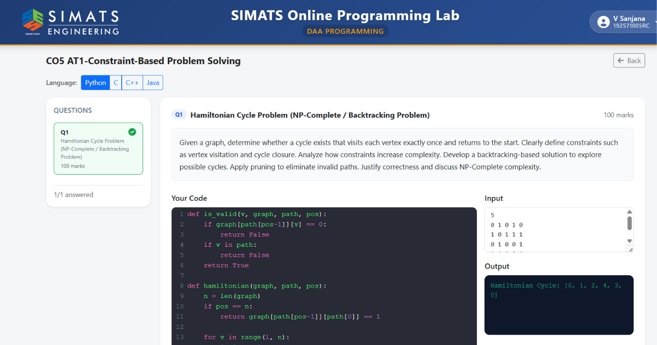

Complexity Summary Table
Complexity Type | Complexity | Explanation
Best Case Time | O(V) | A valid Hamiltonian Cycle is found with very few backtracking steps.
Average Case Time | Exponential | Several possible vertex arrangements may need to be explored.
Worst Case Time | O(V!) | The algorithm may examine almost all possible permutations of vertices.
Path Storage | O(V) | Stores the current sequence of vertices in the Hamiltonian path.
Recursion Stack | O(V) | Maximum recursive depth is equal to the number of vertices.
Auxiliary Space | O(V) | Additional memory used by the backtracking algorithm.
Graph Storage | O(V²) | The adjacency matrix stores connections between every pair of vertices.
Overall Space | O(V²) | Adjacency matrix dominates the additional linear memory.
Final Complexity
Time Complexity: O(V!)
Auxiliary Space Complexity: O(V)
Overall Space Complexity: O(V²)
Time Complexity
The Hamiltonian Cycle Problem checks whether a graph contains a cycle that visits every vertex exactly once and finally returns to the starting vertex.
A backtracking approach is used to construct the Hamiltonian path step by step. At each position in the path, the algorithm tries all possible unvisited vertices and checks whether the selected vertex is connected to the previously selected vertex.
Space Complexity
The space complexity mainly depends on the recursive backtracking stack and the array used to store the current Hamiltonian path.
The algorithm maintains a path array of size V.
For example:
Path = [0, 1, 2, 4, 3]
This array stores the vertices that have been selected so far.
Therefore, the space required for storing the path is:O(V).

